***SHUBHAM GARG***

***9919103057***

***BATCH:F2***

***#Programme 1***

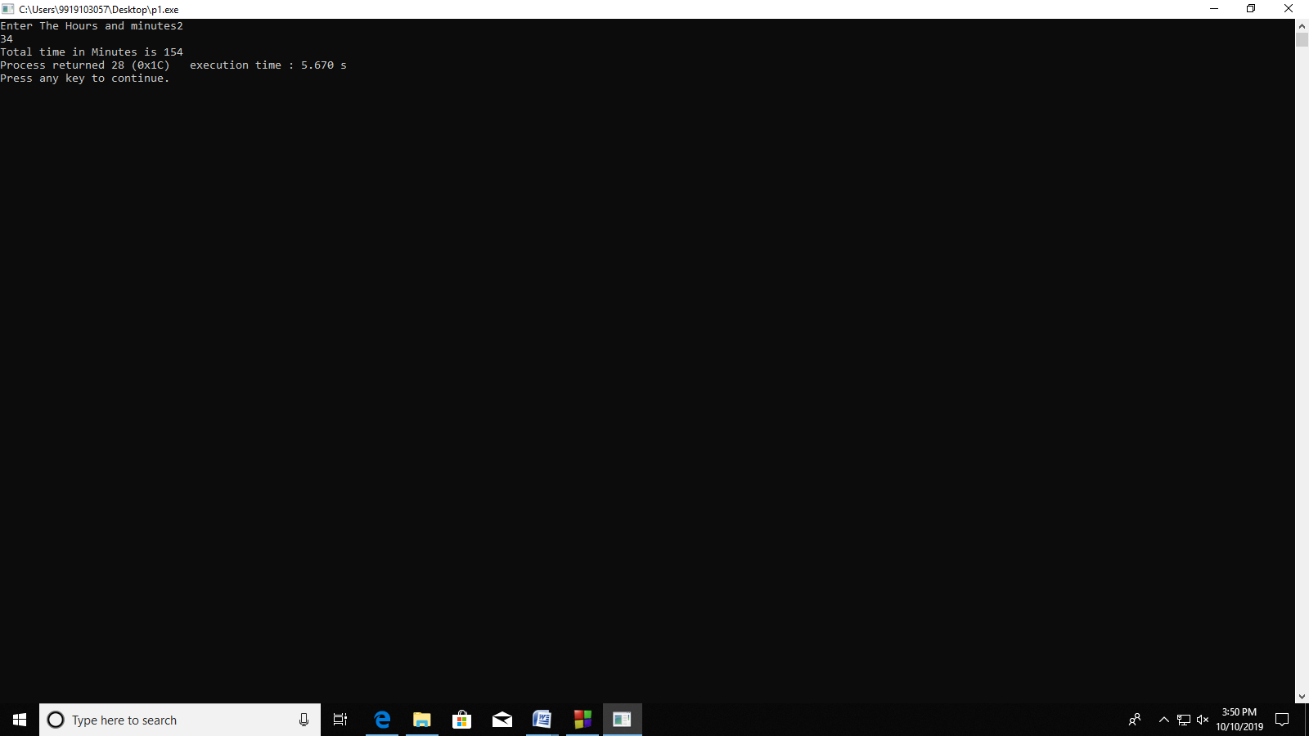

#include <stdio.h>

void main()

{

int hours,min,time;

printf("Enter The Hours and minutes");

scanf("%d %d",&hours,&min);g

time=hours*60+min;

printf("Total time in Minutes is %d",time);

}

***# Programme 2***

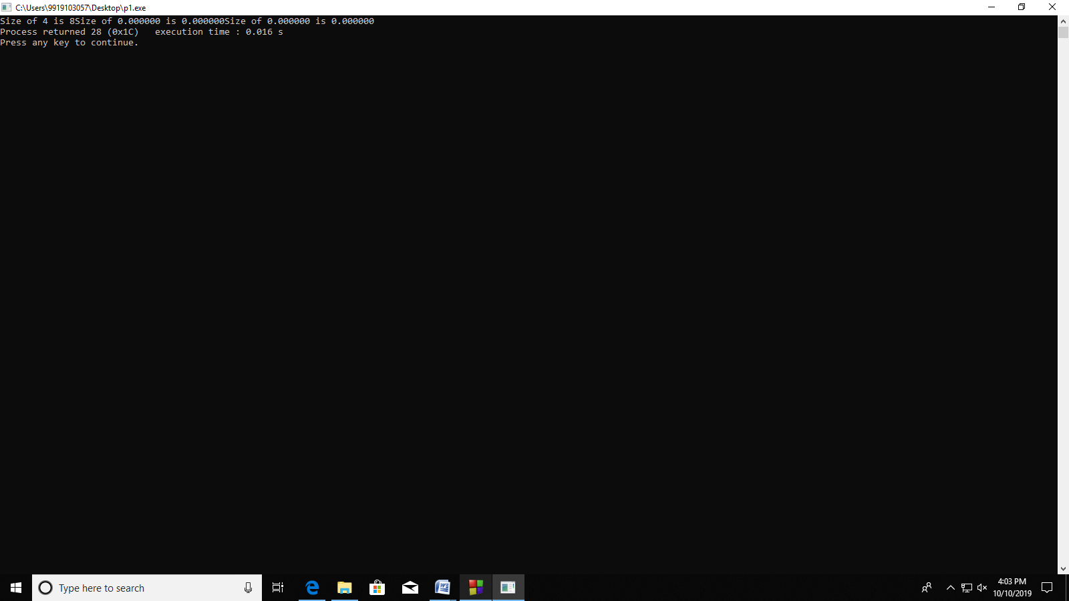

#include <stdio.h>

void main()

{

printf("Size of int is %d",sizeof(int));

printf("Size of float is %f",sizeof(float));

printf("Size of double is %lf",sizeof(double));

}

***#Programme 3***  
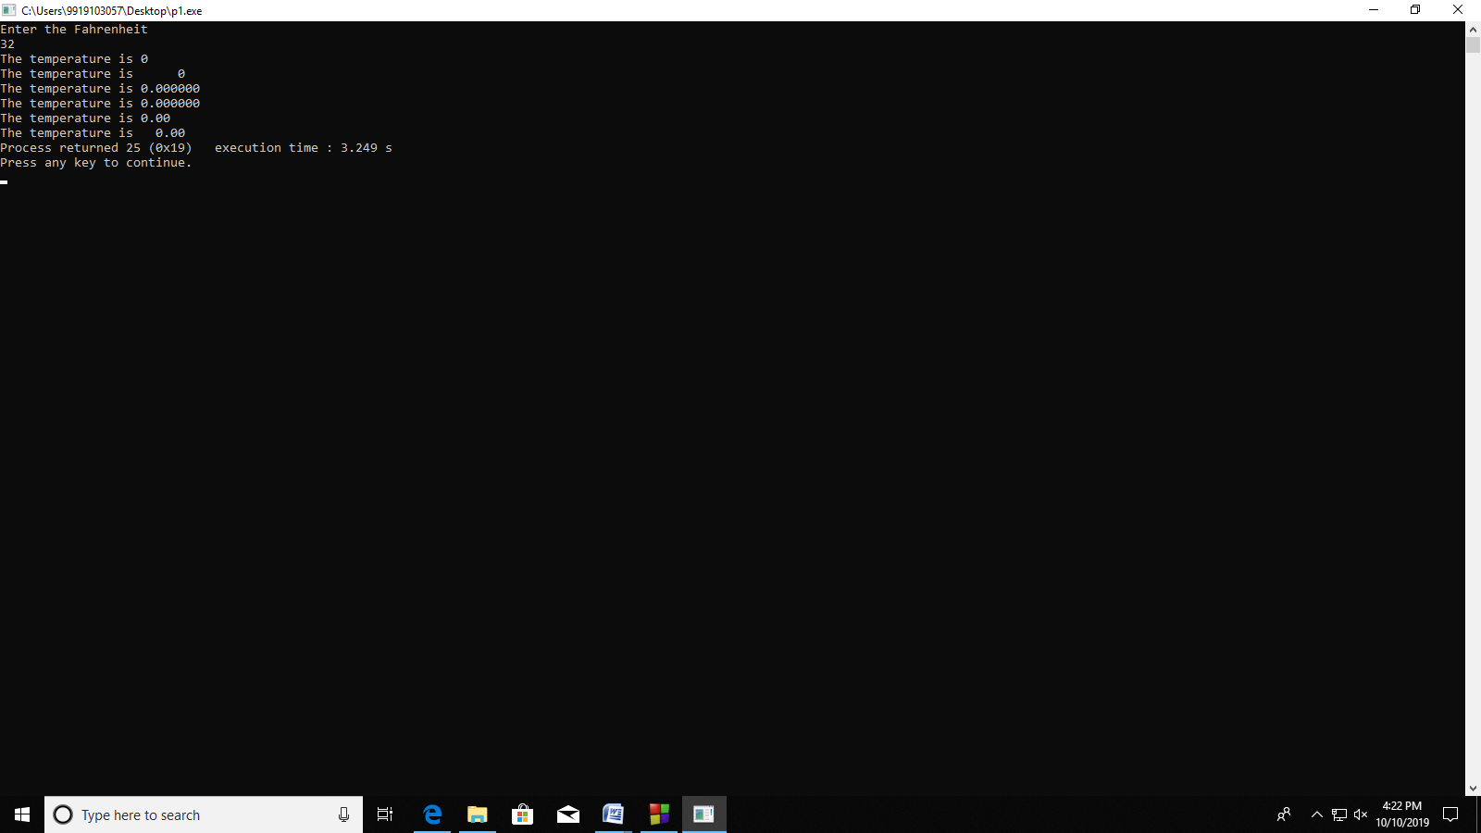

#include <stdio.h>

void main()

{

float c,f;

printf("Enter the Fahrenheit\n");

scanf("%f",&f); c=((f-32)*5)/9;

printf("The temperature is %d\n",c);

printf("The temperature is %6d\n",c);

printf("The temperature is %f\n",c);

printf("The temperature is %6f\n",c);

printf("The temperature is %.2f\n",c);

printf("The temperature is %6.2f",c);

}

***#Programme 4***

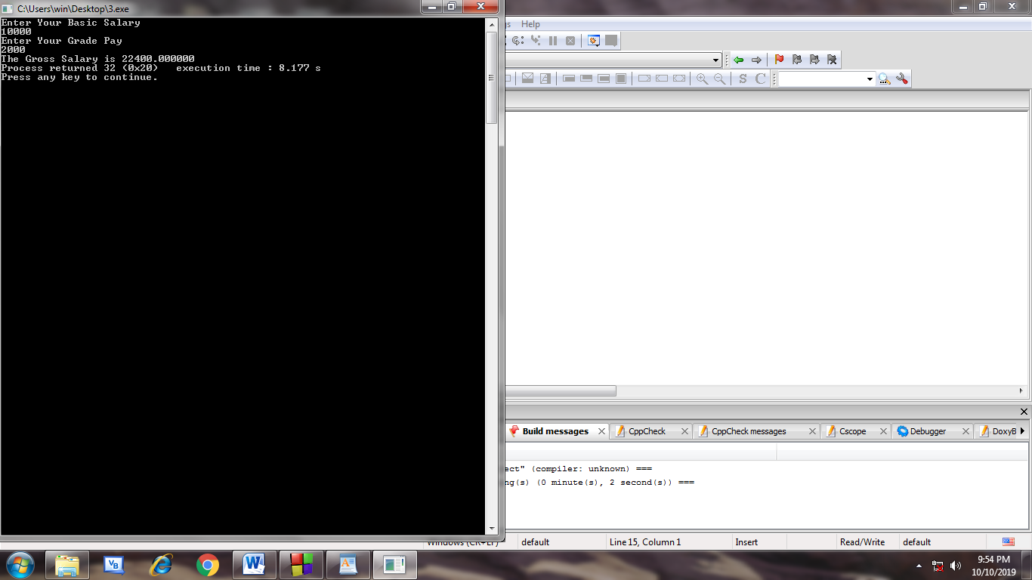

#include <stdio.h>

void main()

{

int basic,gp;

float da,hra,gross;

printf("Enter Your Basic Salary\n");

scanf("%d",&basic);

printf("Enter Your Grade Pay\n");

scanf("%d",&gp);

da=0.8*basic;

hra=0.2*(basic+gp);

gross=da+basic+gp+hra;

printf("The Gross Salary is %f",gross);

}

**#Programme 5**

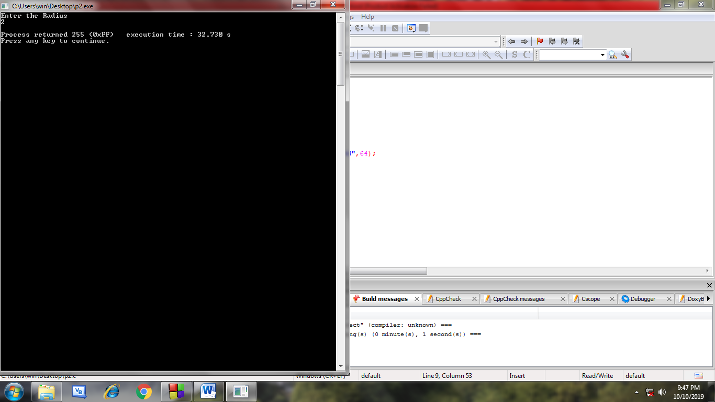

#include <stdio.h>

#include <math.h>

void main()

{

int radius,r;

int n;

printf("Enter the Radius\n");

scanf("%d",radius);

printf("Number of Smaller Radii Ball is %d",64);

}

***#Programme 6***

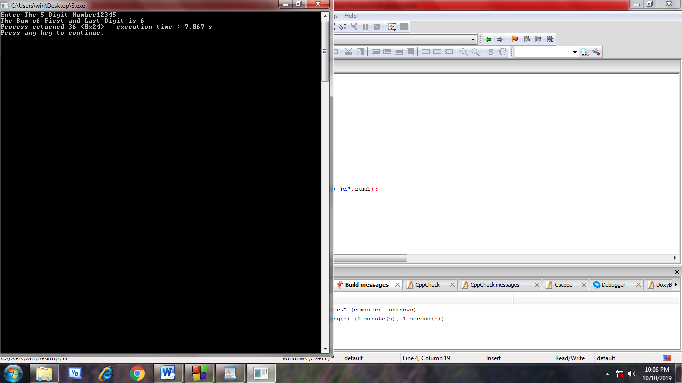

#include <stdio.h>

void main()

{

int n,rem,temp,sum1;

printf("Enter The 5 Digit Number");

scanf("%d",&n);

temp=n;

while(n!=0)

{

rem=n%10;

n=n/10;

}

sum1=rem+(temp%10);

printf("The Sum of First and Last Digit is %d",sum1);

}

***# Programme 7***

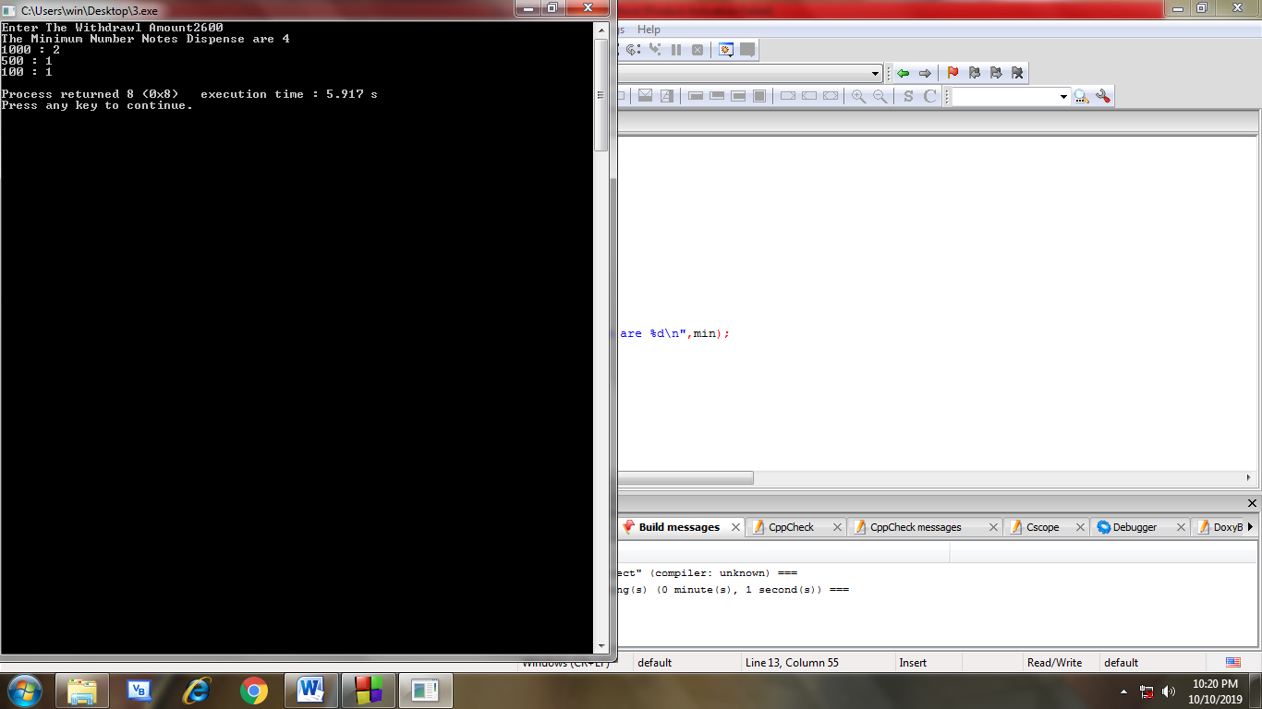

#include <stdio.h>

void main()

{ int amount,th,fv,hn,min;

printf("Enter The Withdrawl Amount");

scanf("%d",&amount);

th=amount/1000;

amount=amount-(1000*th);

fv=amount/500;

amount=amount-(500*fv);

hn=amount/100;

min=th+fv+hn;

printf("The Minimum Number Notes Dispense are %d\n",min);

printf("1000 : %d\n",th);

printf("500 : %d\n",fv);

printf("100 : %d\n",hn);

}